TOPIC 6 : BACKTRACKING
1.
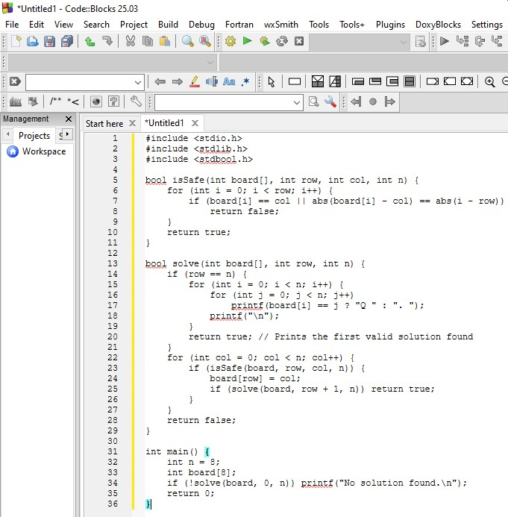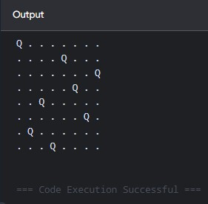
Time Complexity: $O\left(N!\right)$ worst-case
Space Complexity: $O\left(N\right)$

2.
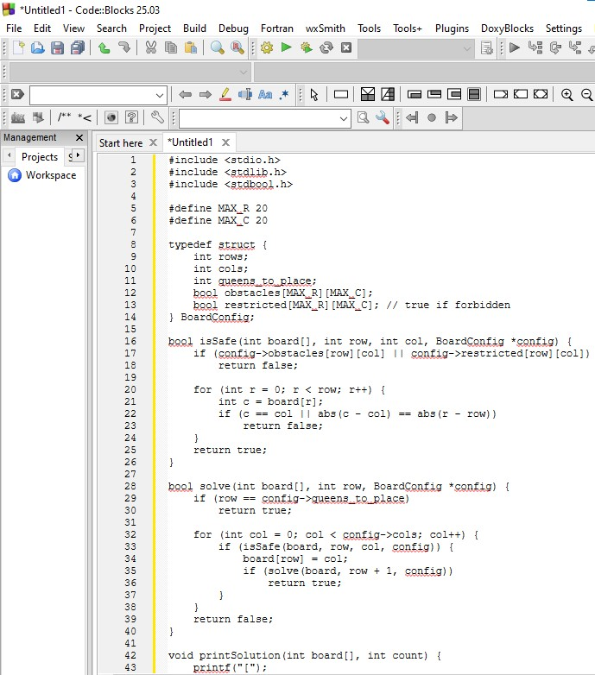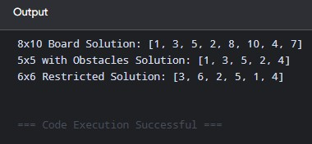
Time Complexity: $O\left(C^{R}\right)$ worst-case search space pruned by constraints
Space Complexity: $O\left(R+R×C\right)$

3.
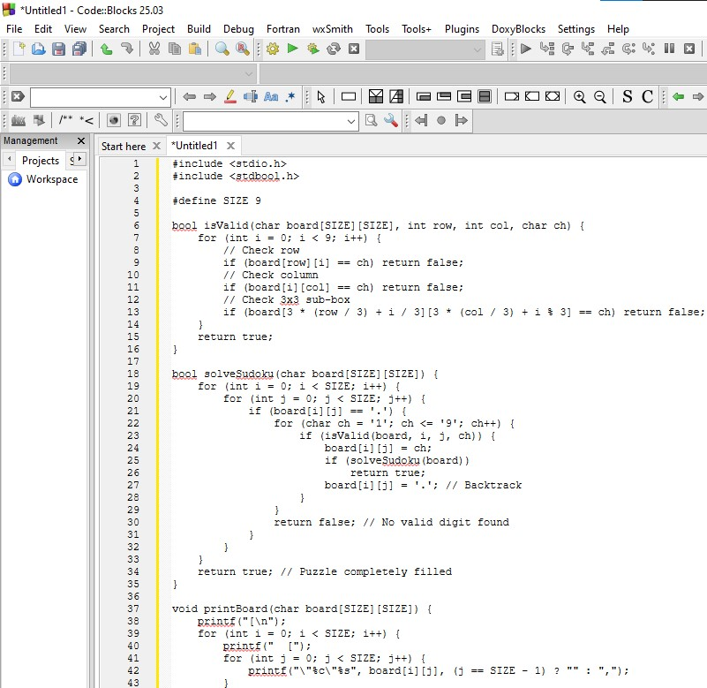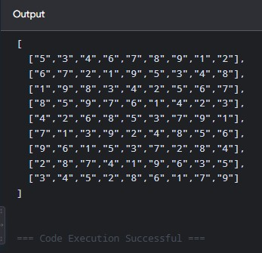
Time Complexity: $O\left(9^{m}\right)$ where $m$ is the number of empty cells
Space Complexity: $O\left(m\right)$
4.
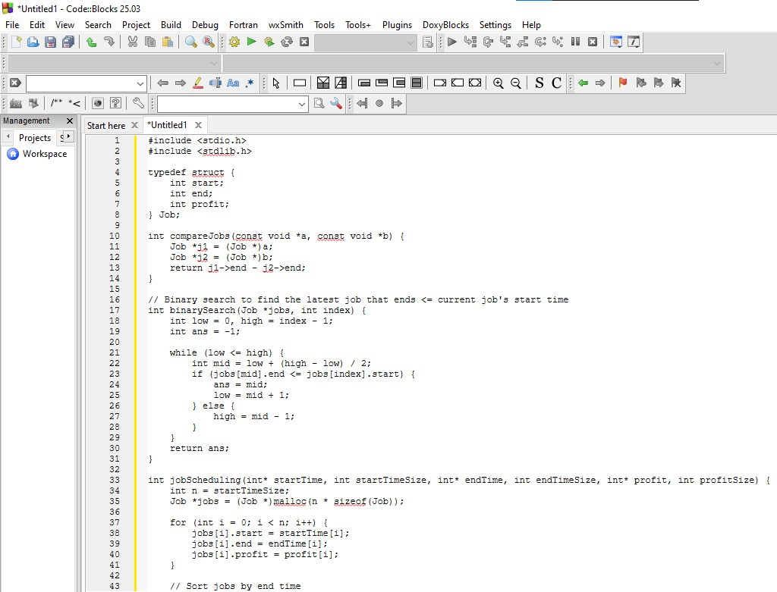
Output:
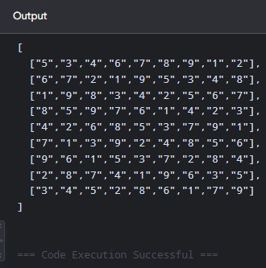
Time Complexity: $O\left(9^{m}\right)$ where $m$ is the number of empty cells
Space Complexity: $O\left(m\right)$

5.
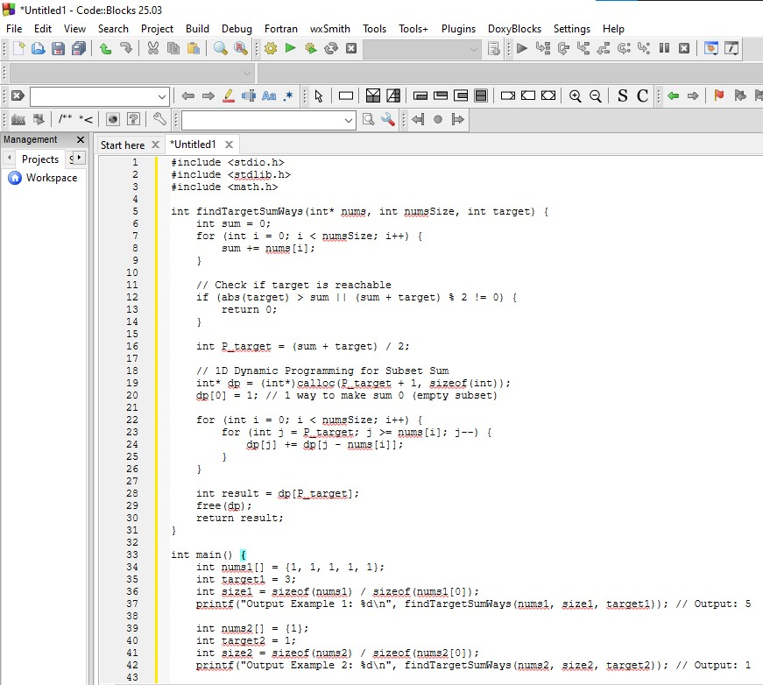
Output:

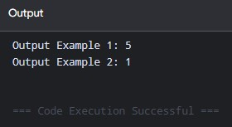

Time Complexity: $O\left(N×S\right)$ where $N$ is numsSize and $S=\frac{\text{sum}\left(\text{nums}\right)+\text{target}}{2}$
Space Complexity: $O\left(S\right)$

6.
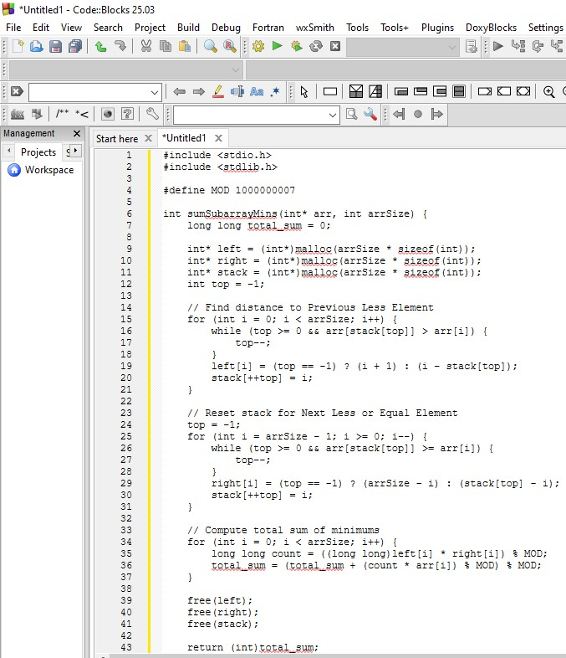
Output:
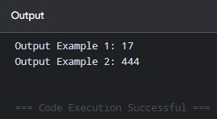
Time Complexity: $O\left(N\right)$ using monotonic stacks
Space Complexity: $O\left(N\right)$

7.
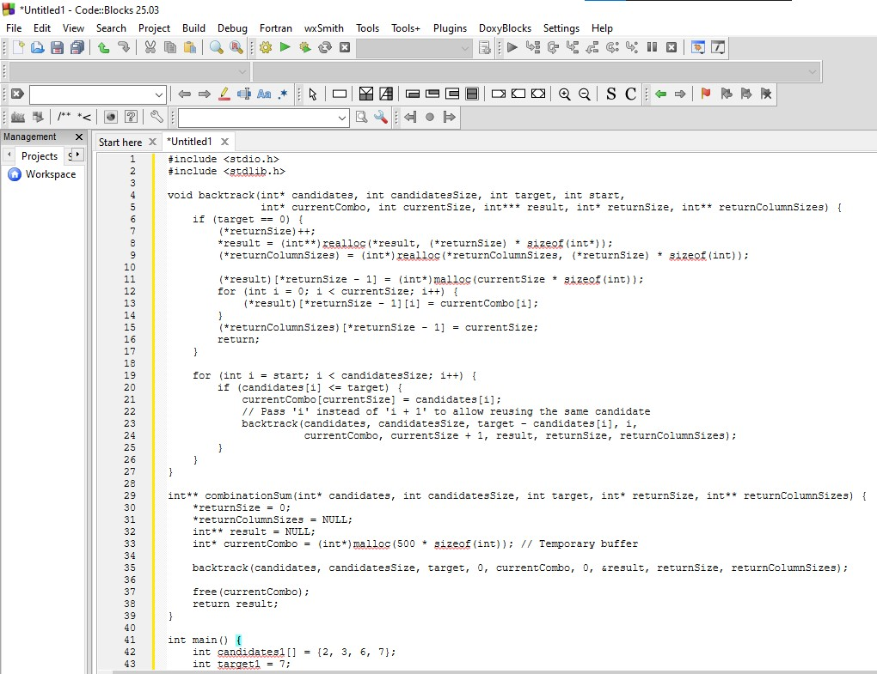
Output:
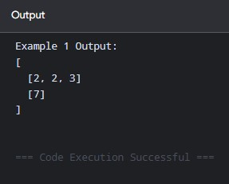
Time Complexity: $O\left(2^{T}\right)$ where $T$ is target / min(candidates)
Space Complexity: $O\left(T\right)$

8.
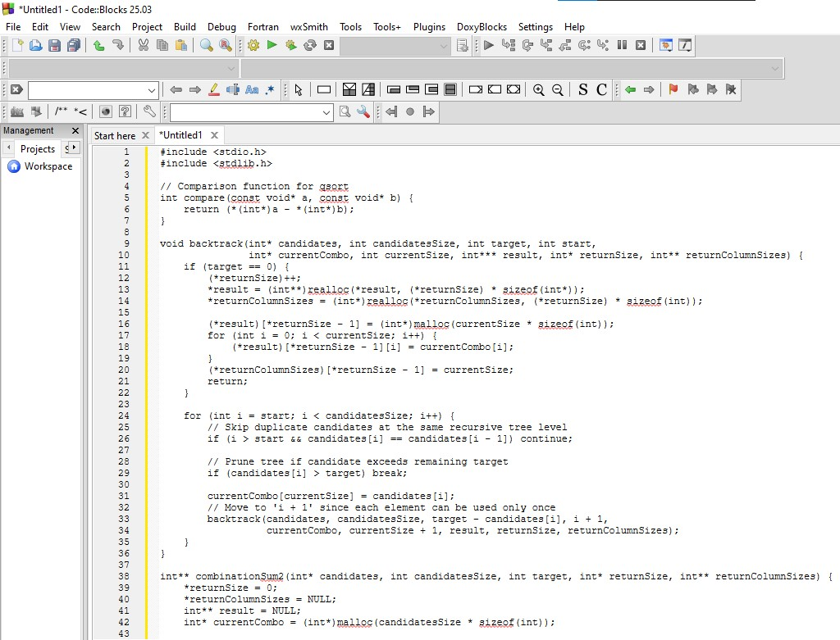
Output:
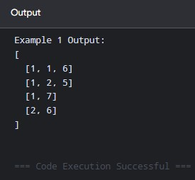
Time Complexity: $O\left(2^{N}\right)$ in the worst case where $N$ is candidatesSize
Space Complexity: $O\left(N\right)$

9.
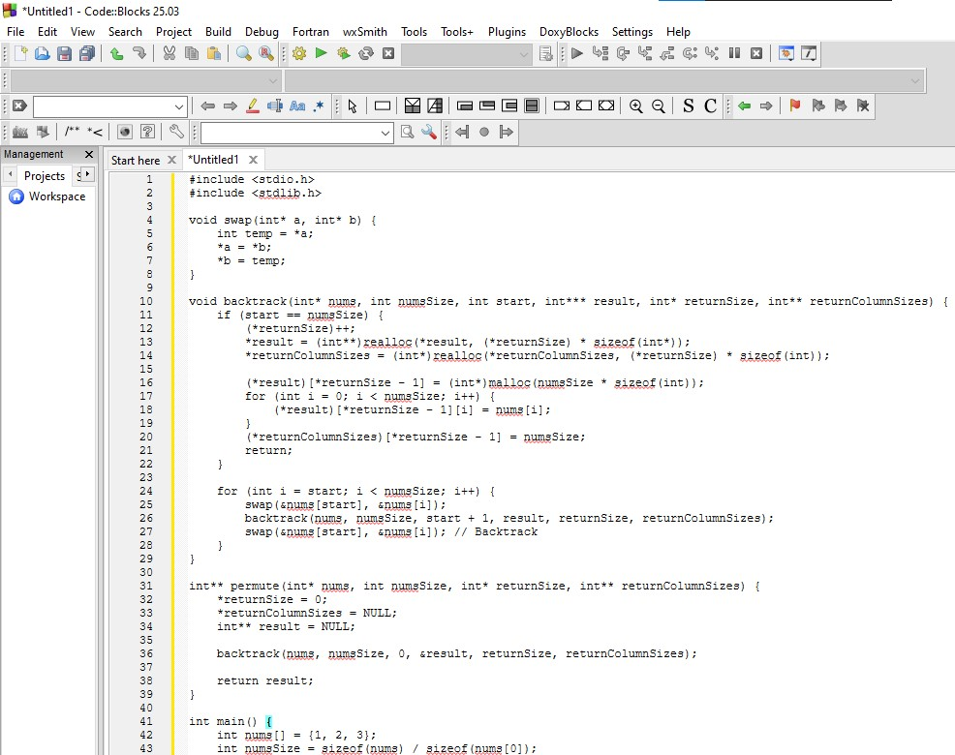
Output:
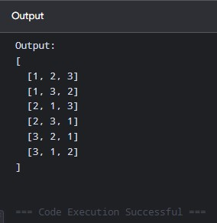
Time Complexity: $O\left(N⋅N!\right)$ where $N$ is numsSize
Space Complexity: $O\left(N\right)$

10.
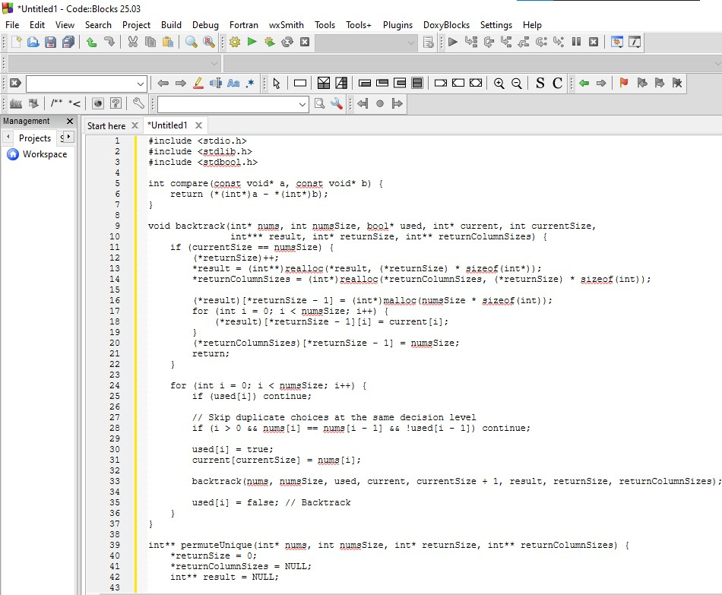
Output:
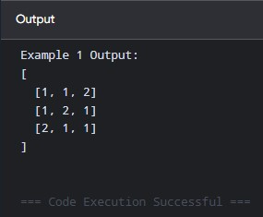
Time Complexity: $O\left(N⋅N!\right)$ worst-case where $N$ is numsSize
Space Complexity: $O\left(N\right)$

11.
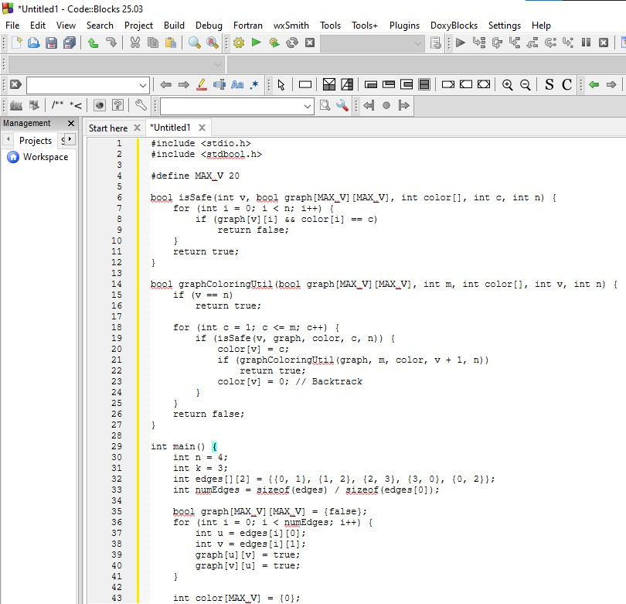
Output:
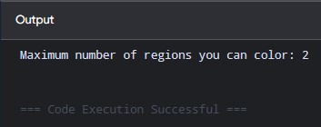
Time Complexity: $O\left(k^{N}\right)$ for $k$-coloring check via backtracking
Space Complexity: $O\left(N+N^{2}\right)$

12.
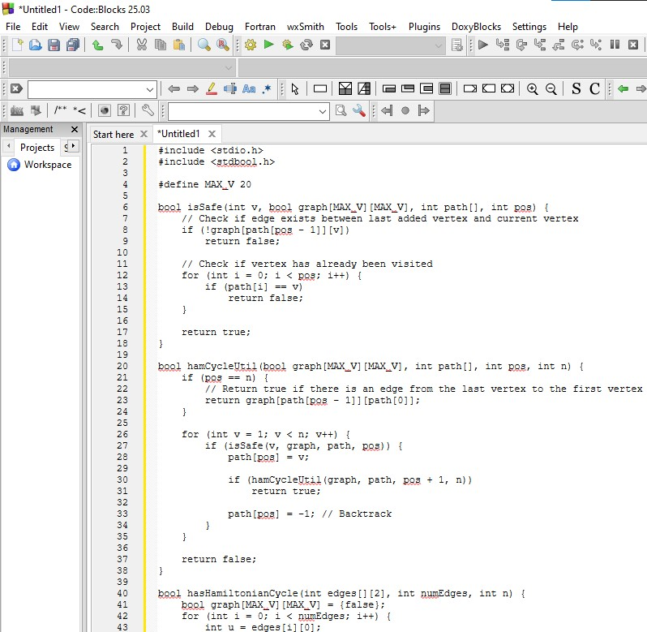
Output:
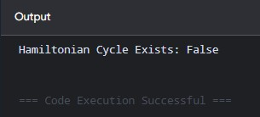
Time Complexity: $O\left(N!\right)$ worst-case search space
Space Complexity: $O\left(N+N^{2}\right)$

13.
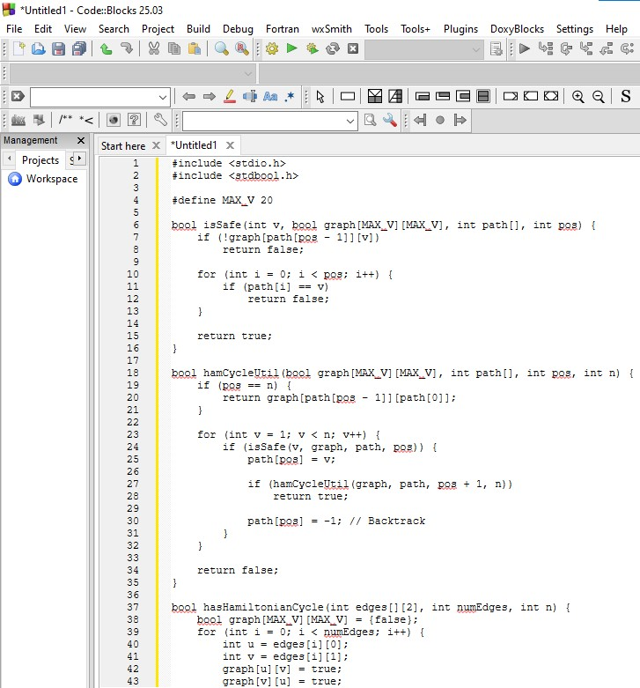
Output:
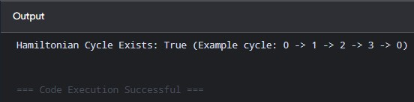
Time Complexity: $O\left(N!\right)$ worst-case state traversal
Space Complexity: $O\left(N+N^{2}\right)$

14.
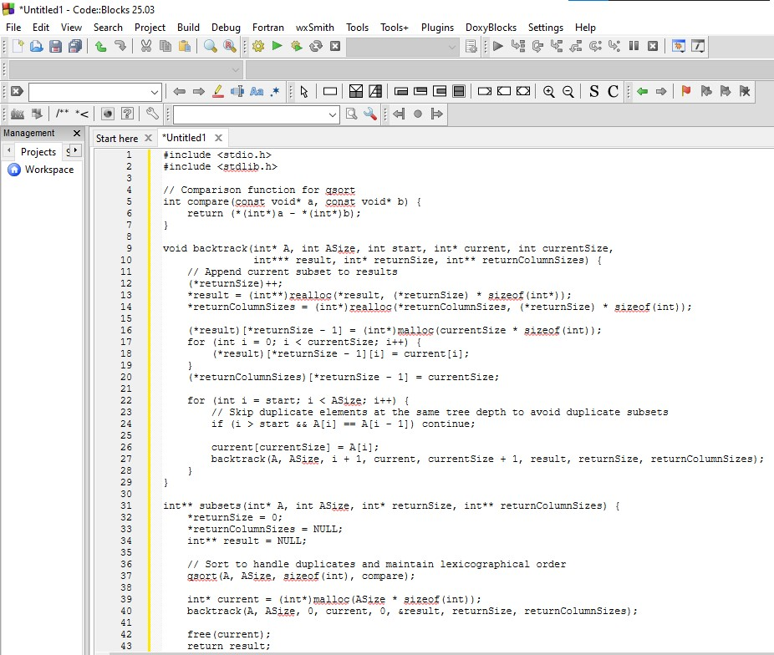
Output:
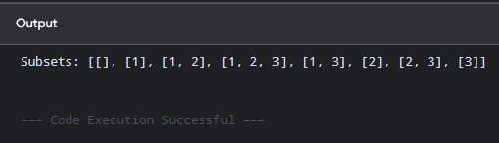
Time Complexity: $O\left(N⋅2^{N}\right)$ where $N$ is the number of elements in $S$
Space Complexity: $O\left(N\right)$

15.
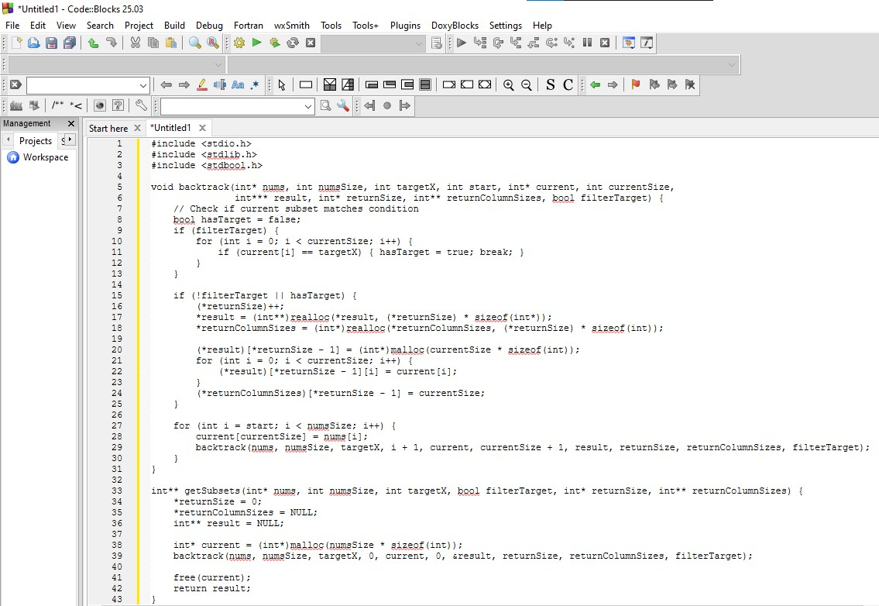
Output:
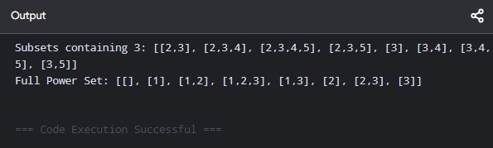
Time Complexity: $O\left(N⋅2^{N}\right)$ where $N$ is the number of elements
Space Complexity: $O\left(N\right)$

16.
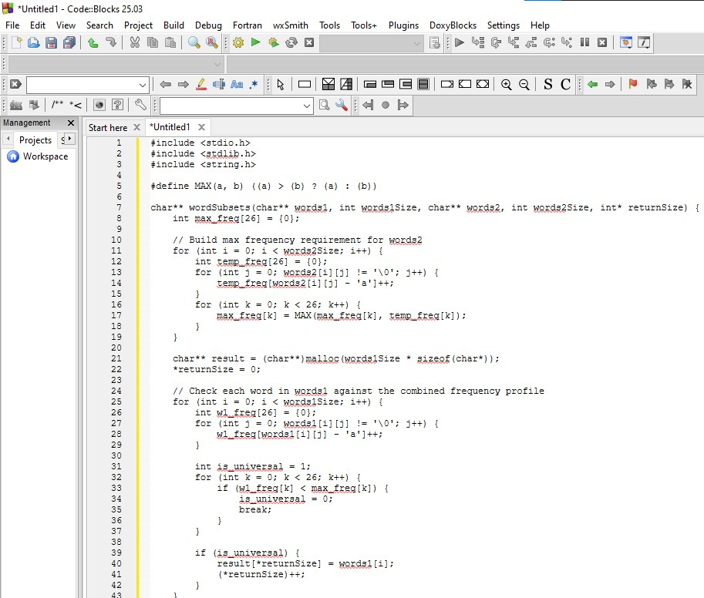
Output:
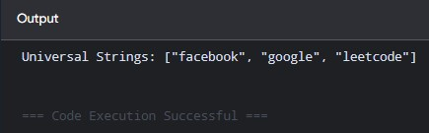
Time Complexity: $O\left(N_{1}⋅L_{1}+N_{2}⋅L_{2}\right)$ where $N_{1},N_{2}$ are lengths of words1, words2 and $L_{1},L_{2}$ are max word lengths
Space Complexity: $O\left(1\right)$

